**NOISE POLLUTION MONITORING**

**Problem statement:**

Develop an IoT-based system to continuously monitor and assess noise pollution in urban areas to ensure a quieter and healthier environment. The system should collect real-time data from various noise sensors, process and analyze the data, and provide actionable insights to mitigate noise pollution. This problem statement can serve as a starting point for designing a noise pollution monitoring system using IoT technology. You can further refine it based on specific requirements, objectives, and constraints of your project.

**Problem identified :**

The current methods of noise pollution monitoring are often manual, infrequent, and lack real-time data. This leads to a lack of accurate information about noise levels and hinders the ability to take timely actions to reduce noise pollution in urban areas.This problem highlights the need for a more efficient and effective noise monitoring system using IoT to address the limitations of traditional methods.

**Introduction:**

noise pollution has become a pressing concern, affecting the well-being of people and the environment. Traditional noise monitoring methods are often outdated and fail to provide real-time insights. To tackle this issue, we propose an innovative approach that leverages the power of IoT technology to continuously monitor and analyze noise levels in urban areas. This IoT-based system offers the potential to enhance our understanding of noise pollution, enabling timely interventions to create quieter and healthier urban environments.

**LITRATURE SURVEY**

**IoT Sensors for Noise Monitoring:**

IoT sensors for noise monitoring typically use microphones to capture sound. These sensors convert acoustic signals into electrical signals, which are then processed and transmitted to a central hub or cloud platform. Some advanced sensors may incorporate additional features like frequency analysis and ambient temperature measurement for more comprehensive data. Integration with IoT platforms enables real-time monitoring, data analytics, and the generation of actionable insights to manage and mitigate noise pollution. Discuss various types of sensors used in IoT-based noise pollution monitoring systems, such as microphones, sound level meters, and acoustic sensors.

**Data Collection and Transmission:**

In noise monitoring using IoT, data collection involves sensors capturing sound levels in the environment. These sensors convert analog signals into digital data, which is then processed for analysis. The collected data is transmitted to a central hub or cloud platform using communication protocols like MQTT or HTTP. This enables real-time monitoring and allows for storage and analysis of historical data. The central system can then generate reports, alerts, or visualizations based on the collected information, aiding in effective noise pollution management. Explore how IoT devices collect noise data and transmit it to a central server or cloud platform for analysis.

**Communication Protocols:**

Common communication protocols in noise pollution monitoring using IoT include MQTT (Message Queuing Telemetry Transport) and HTTP (Hypertext Transfer Protocol). MQTT is often preferred for its lightweight and efficient publish-subscribe model, making it suitable for real-time data transmission. HTTP is widely used for its simplicity and compatibility, allowing devices to send noise data to a central server for analysis. These protocols facilitate seamless communication between noise sensors and central systems, enabling effective monitoring and management of noise pollution. Investigate the communication protocols used, such as Wi-Fi, Lora, or cellular networks, to transfer data from the sensors to the cloud.

**Cloud-Based Data Processing:**

Cloud-based data processing in noise pollution monitoring involves sending collected noise data to a cloud platform for analysis and storage. The cloud system processes this data using algorithms to identify patterns, trends, and anomalies in noise levels. It allows for real-time monitoring, historical data storage, and the generation of reports. Cloud platforms like AWS, Azure, or Google Cloud provide scalable and secure environments for efficient noise pollution management. This approach enables accessibility, flexibility, and the ability to integrate data from multiple monitoring locations. Describe how noise data is processed and analyzed in the cloud, including noise level calculations and pattern recognition.

**Data Visualization:**

Data visualization in noise pollution monitoring involves representing collected data in graphical or visual formats for easy interpretation. It can include charts, graphs, and maps illustrating noise levels over time or across different locations. Visualizations help stakeholders, urban planners, and policymakers comprehend trends, identify noise hotspots, and make informed decisions for mitigating noise pollution. Tools like graphs depicting noise levels throughout the day or heat maps showcasing intensity variations contribute to a more accessible understanding of the data. Discuss methods and tools for visualizing noise pollution data, including web-based dashboards and mobile apps.

**Case Studies and Applications:**

Case study in noise pollution monitoring is the use of IoT sensors in urban areas. For instance, in Barcelona, Spain, smart city initiatives have employed sensors to monitor noise levels across the city. These sensors provide real-time data, allowing city officials to identify noisy areas, implement targeted interventions, and improve overall urban planning.

Another application is in transportation. Cities like London have utilized noise monitoring systems along major roadways and airports to assess the impact of traffic and aircraft noise on residents. This data informs policies to reduce noise exposure and enhance the quality of life for affected communities. In industrial settings, noise monitoring is crucial for ensuring workplace safety and compliance with regulations. IoT-based solutions have been implemented in factories to continuously monitor noise levels, triggering alerts when thresholds are exceeded to protect workers’ hearing health. Highlight real-world case studies where IoT-based noise pollution monitoring systems have been deployed in urban areas, industrial zones, or other environments.

**Benefits and Challenges:**

Monitoring noise pollution helps identify and address high-exposure areas, promoting better public health outcomes. Collected data enables policymakers to formulate evidence-based regulations and interventions to mitigate noise pollution. Noise monitoring contributes to better urban planning by identifying areas prone to noise issues, leading to more sustainable and livable city designs.

Ensuring the accuracy of collected data requires careful calibration and maintenance of monitoring devices. Continuous monitoring may raise privacy concerns, especially if sensors are placed in residential areas. Deploying and maintaining a widespread noise monitoring system can be expensive, limiting its adoption in some regions.

**Future Trends and Research Directions:**

Continued development of more sophisticated sensors for enhanced accuracy, extended frequency range, and additional environmental parameter measurements. Integration of edge computing capabilities into sensors for on-device data processing, reducing the need for constant communication with central systems and minimizing latency. Collaboration with broader smart city initiatives, incorporating noise data into comprehensive urban planning strategies for more sustainable and livable cities.

Research directions may focus on addressing challenges such as privacy concerns, developing cost-effective monitoring solutions, and investigating the long-term health impacts of chronic exposure to different noise patterns. Additionally, exploring the social and psychological aspects of noise pollution and its impact on community well-being could be an area of growing interest.

**Design thinking**

**Design thinking approach:**

**Emphasis**:

Prioritize the deployment of IoT-based noise sensors in key urban areas to accurately capture and monitor noise levels, focusing on locations with high population density and potential environmental impact.

**Action**:

Implement a comprehensive IoT noise pollution monitoring system by strategically installing sensors, connecting them to a cloud platform for real-time data analysis, and developing user-friendly visualizations. Collaborate with local authorities and communities to address noise-related concerns and actively promote sustainable urban planning based on monitoring insights.

**Problem statement:**

Precisely measure noise levels in urban areas using IoT sensors. Enable continuous, real-time monitoring for immediate awareness.Provide data for evidence-based noise pollution regulations and interventions.

**Idea:**

Implement a mobile IoT noise pollution monitoring unit equipped with sensors that can be deployed in various locations for on-the-go data collection.

**Action:**

Develop a compact, battery-powered IoT device with noise sensors, microcontroller, and communication module.

**Test:**

Deploy the mobile units in diverse environments, such as urban centers, parks, and industrial areas.

**Prototype:**

Develop a compact IoT noise pollution monitoring prototype comprising noise sensors, a microcontroller (e.g., Raspberry Pi), and wireless communication (e.g., Wi-Fi or Bluetooth) for data transmission.

**Action**:

Connect noise sensors to the microcontroller, ensuring proper calibration for accurate noise measurements.

Implement a simple algorithm on the microcontroller to process noise data and prepare it for transmission.

**Test:**

Compare the prototype’s noise measurements with reference measurements to validate sensor accuracy.

Assess the reliability of data transmission by deploying the prototype in various environments with different connectivity conditions.

**The project overview**

Noise pollution monitoring using IoT involves the deployment of sensors that capture and analyze environmental noise levels in real-time. These sensors are connected to the Internet of Things (IoT) network, enabling data collection, transmission, and analysis. Here’s a breakdown of the key components and steps involved in controlling noise pollution through IoT:

**Sensor Deployment:**

Place noise sensors strategically in areas prone to high noise levels, such as urban centers, industrial zones, or near highways.

These sensors should be capable of capturing various parameters like decibel levels, frequency, and duration of noise events.

**IoT Connectivity:**

Connect the noise sensors to the IoT network, allowing them to communicate and transmit data over the internet.

Common communication protocols include MQTT or HTTP, facilitating seamless integration with IoT platforms.

**Cloud-based Storage and Processing:**

Store the collected noise data in cloud-based servers for easy accessibility and scalability.

Utilize cloud computing resources to process and analyze the data, identifying patterns, trends, and potential sources of noise pollution.

**Alerts and Notifications:**

Implement an alert system based on predefined thresholds for noise levels. When certain thresholds are exceeded, the system triggers notifications to relevant authorities or stakeholders.

Alerts can be sent via emails, messages, or integrated into existing communication channels.

**Automation and Control Measures:**

Integrate with smart systems or automation processes to implement control measures in response to excessive noise levels.

For example, automatic adjustment of traffic signal timings to reduce congestion-induced noise during peak hours.

**Regulatory Compliance:**

Ensure that the noise monitoring system complies with relevant regulations and standards set by environmental authorities.

The collected data can be used for regulatory reporting, demonstrating adherence to noise pollution limits.

**Iot devices setup**

**Components:**

* ESP32
* Wi fi
* Lcd display
* Buzzer
* Sound sensor
* Power supply
* LED

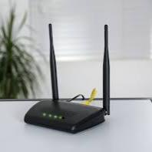**Wi fi**

**Lcd display**

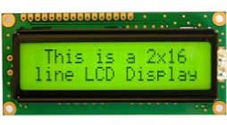

**Buzzer**

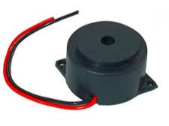

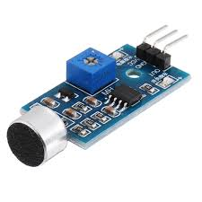**Sound sensor**

**Power supply**

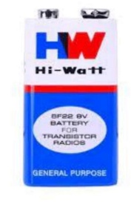

Connect the TX pin of the ESP8266 to the pin 10 of the Arduino

And the RX pin of the esp8266 to the pin 9 of Arduino through

The resistors. ESP8266 Wi-Fi module gives your projects access

To Wi-Fi or internet. It is a very cheap device and make your

Projects very powerful. It can communicate with any

Microcontroller and it is the most leading devices in the IOT

Platform. Learn more about using ESP8266 with Arduino here.

Then we will connect the MQ135 sensor with the Arduino.

Connect the VCC and the ground pin of the sensor to the 5V

And ground of the Arduino and the Analog pin of sensor to the

A0 of the Arduino. Connect a buzzer to the pin 8 of the Arduino .Which will start to beep when the condition becomes true. In Last, we will connect LCD with the Arduino.

**Code implementation**

#include <LiquidCrystal.h> // include the LiquidCrystal library

Const int micPin1 = A0; // define the pin for the first microphone

Const int micPin2 = A1; // define the pin for the second microphone

Const int micPin3 = A2; // define the pin for the third microphone

Const int buzzerPin = 9; // define the pin for the buzzer

Const int ledPin = 6; // define the pin for the LED

Const int contrast = 50; // define the LCD contrast

LiquidCrystal lcd(12, 11, 5, 4, 3, 2); // initialize the LCD display

Void setup() {

pinMode(buzzerPin, OUTPUT); // set the buzzer pin as output

pinMode(ledPin, OUTPUT); // set the LED pin as output

lcd.begin(16, 2); // initialize the LCD display

analogWrite(6,contrast); // set the LCD contrast

Serial.begin(9600); // initialize the serial monitor

}

Void loop() {

// read the values from the microphones

Int micValue1 = analogRead(micPin1);

Int micValue2 = analogRead(micPin2);

Int micValue3 = analogRead(micPin3);

// calculate the sound levels in dB for each microphone

Float voltage1 = micValue1 * 5.0 / 1024.0; // convert the first microphone value to voltage (5V reference)

Float voltage2 = micValue2 * 5.0 / 1024.0; // convert the second microphone value to voltage (5V reference)

Float voltage3 = micValue3 * 5.0 / 1024.0; // convert the third microphone value to voltage (5V reference)

Float dB1 = 20 * log10(voltage1/0.0063); // calculate the sound level in dB for the first microphone

Float dB2 = 20 * log10(voltage2/0.0063); // calculate the sound level in dB for the second microphone

Float dB3 = 20 * log10(voltage3/0.0063); // calculate the sound level in dB for the third microphone

// calculate the average sound level in dB for all microphones

Float averageDB = (dB1 + dB2 + dB3) / 3;

// display the sound level on the LCD display and the serial monitor

Lcd.setCursor(0, 0); // set the cursor to the first row of the LCD display

Lcd.print(“Sound Level: “); // print the text “Sound Level: “ on the LCD display

Lcd.setCursor(0, 1); // set the cursor to the second row of the LCD display

Lcd.print(averageDB); // print the average sound level on the LCD display

Serial.println(“Sound Level: “); // print the text “Sound Level: “ on the serial monitor

Serial.println(averageDB); // print the average sound level on the serial monitor

// control the LED and the buzzer based on the sound level

If (averageDB > 70) { // if the sound level is higher than 70 dB

digitalWrite(ledPin, HIGH); // turn the LED on

tone(buzzerPin, 1000, 500); // turn the buzzer on

} else { // if the sound level is lower than 70 dB

digitalWrite;

}

}

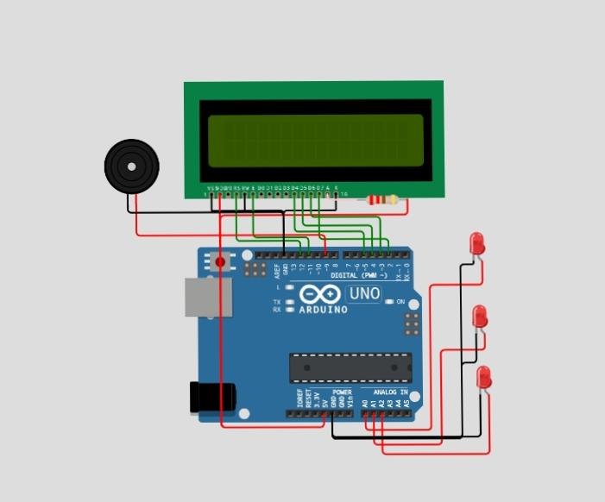**Circuit diagram**

**Circuit output:**

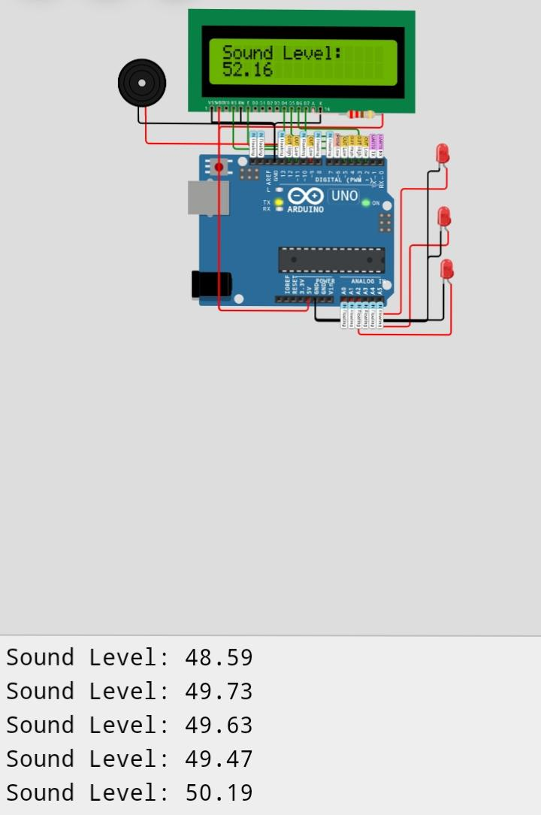

**Platform development**

**Sensor Integration**: Utilize IoT-enabled noise sensors that can measure the ambient noise levels. These sensors should be capable of capturing data at regular intervals.

**Connectivity:** Implement a communication protocol (e.g., MQTT, CoAP) to transmit data from the noise sensors to a central server or cloud platform. This could involve Wi-Fi, cellular, or other IoT communication technologies.

**Data Storage**: Set up a database to store the collected noise data. This can be a cloud-based solution for scalability and accessibility.

**Cloud Platform**: Employ a cloud service (e.g., AWS, Azure, Google Cloud) to manage and process the data. This platform can handle data storage, analytics, and provide a scalable infrastructure.

**User Interface**: Develop a user-friendly interface, such as a web or mobile application, to visualize the monitored noise data. This interface can provide real-time information, historical trends, and customizable alerts.

**Alerting System** :Integrate an alerting system to notify users or relevant authorities when noise levels exceed predefined thresholds. This could be through push notifications, emails, or other communication channels.

**Mapping Integration**: Optionally, include mapping capabilities to display noise levels geographically. This can be useful for identifying specific noise hotspots.

**Security Measures:** Implement robust security measures to protect the collected data, ensuring the privacy and integrity of the information.

**Power Management:** Address power consumption concerns, especially for remote or battery-operated sensors. Efficient power management strategies can prolong the lifespan of the sensors.

**Project explanation**

**Components:**

**1.LED**

Provides visual feedback to indicate the operational status of the fountain.

**2.**. **ESP32 Board:**

Functions as the core controller, processing sensor data and controlling the connected components.

**3.buzzer**

Buzzers are devices that produce a buzzing sound.

**4.Sound sensor:**

A sound sensor, simply put, detects sound waves and converts them into electrical signals.

**Data Acquisition**

Continuous collection of noise data.

**Analog-to-Digital Conversion**:

Conversion of analog data to digital format.

**Microcontroller/Processor**:

Data processing and IoT communication.

**IoT Connectivity:**

Wireless communication to transmit data.

**Data Storage:**

Central server or cloud-based database for storing data.

**Maintenance and Calibration:**

Ensuring sensor accuracy.

**User Access:**

Providing access to authorized users for real-time and historical data.

This system aids in making informed decisions to address noise-related issues and ensure a quieter, healthier environment for communities.

**Objective**:

To monitor and manage noise pollution in various environments, ensuring compliance with noise regulations and improving the quality of life for resident.

**Conclusion:**

In conclusion, the implementation of a noise pollution monitoring system using IoT technology offers several significant advantages. It allows for real-time data collection and analysis, aiding in the identification of noise sources and patterns. This can be valuable for urban planning, public health, and environmental conservation. Furthermore, IoT-based systems are cost-effective, scalable, and can provide actionable insights to mitigate noise pollution. However, it’s crucial to consider privacy and data security issues when deploying such systems. Overall, IoT-based noise pollution monitoring systems have the potential to enhance our understanding of and response to this pervasive environmental issue.